**Day 14 Assignment**

**Jenkins setup and installation:**

**Master node:**

**Installed java and Jenkins in master node**

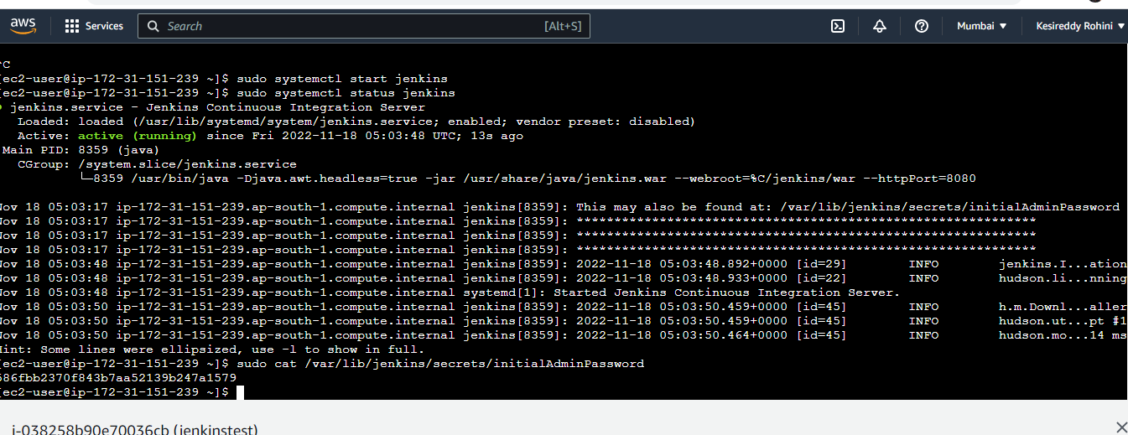

**Worker node:**

**Installed java and connected to master**

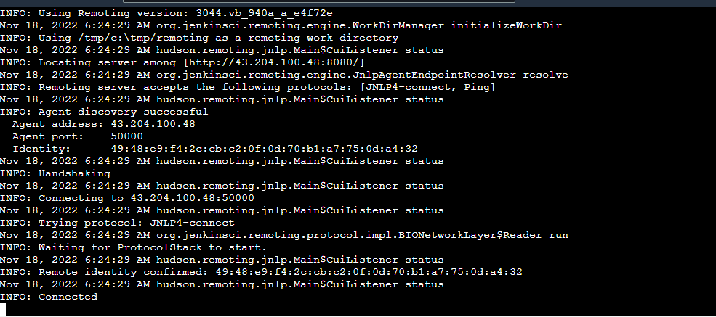

**Jenkins login dashboard:**

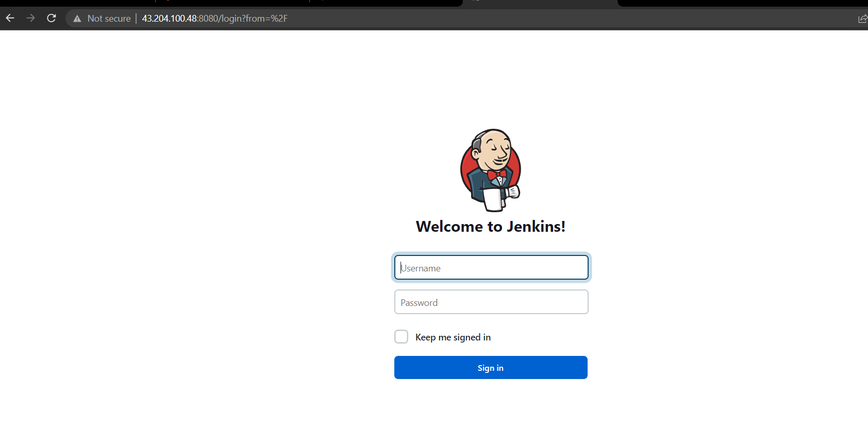

**Master and slave nodes:**

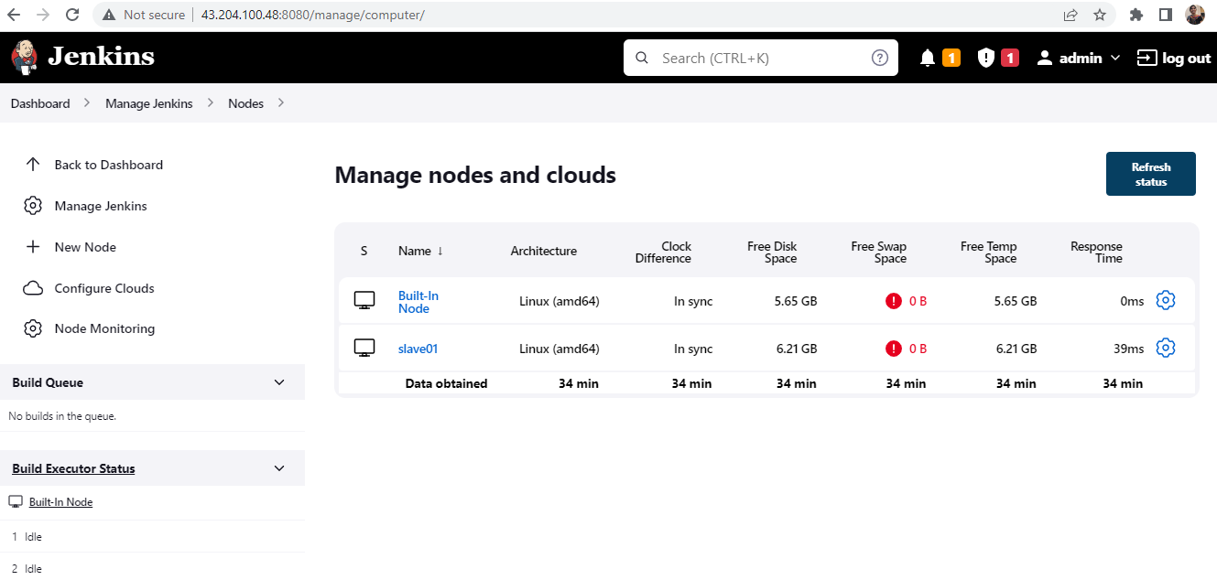

**Sample free style project:**

**Created free style project name newjob1**

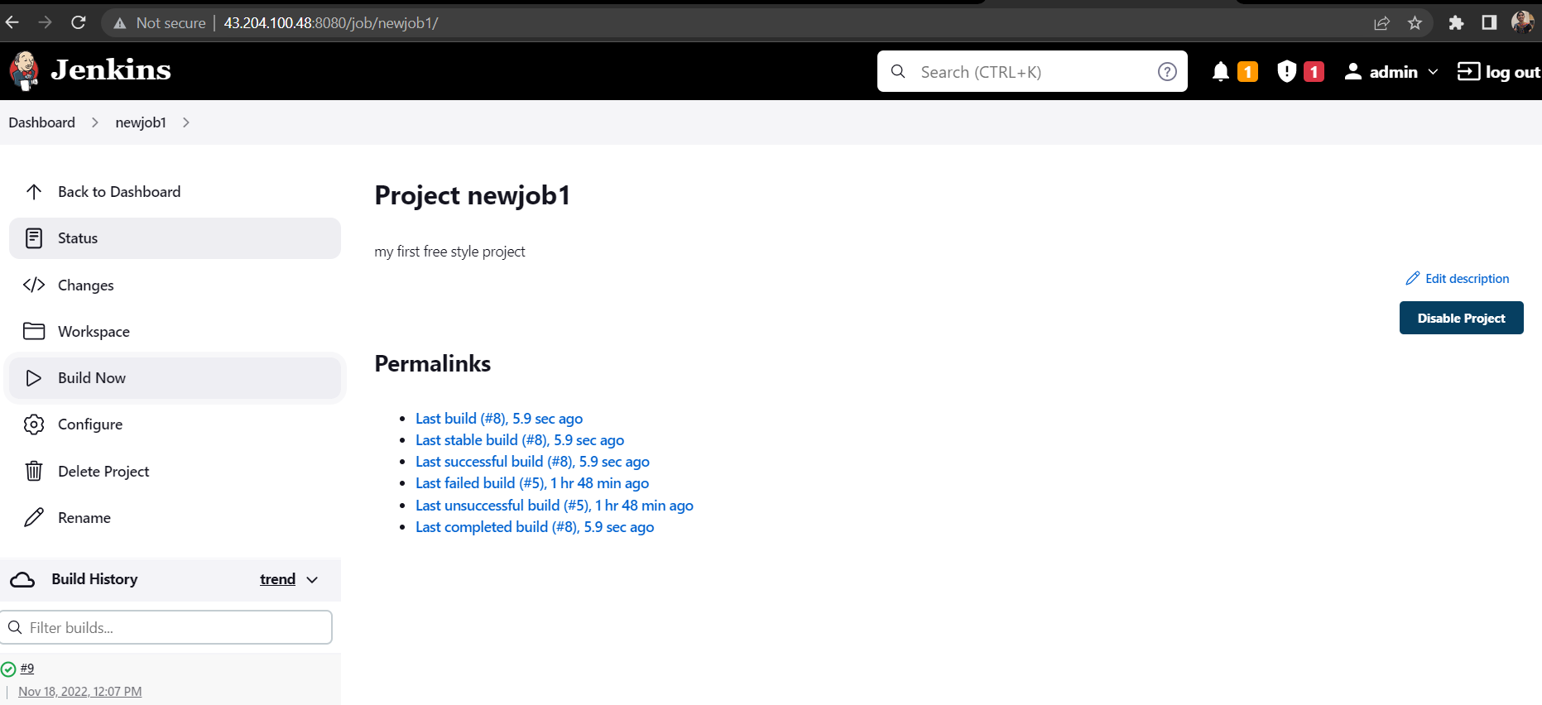

**Console o/p:**

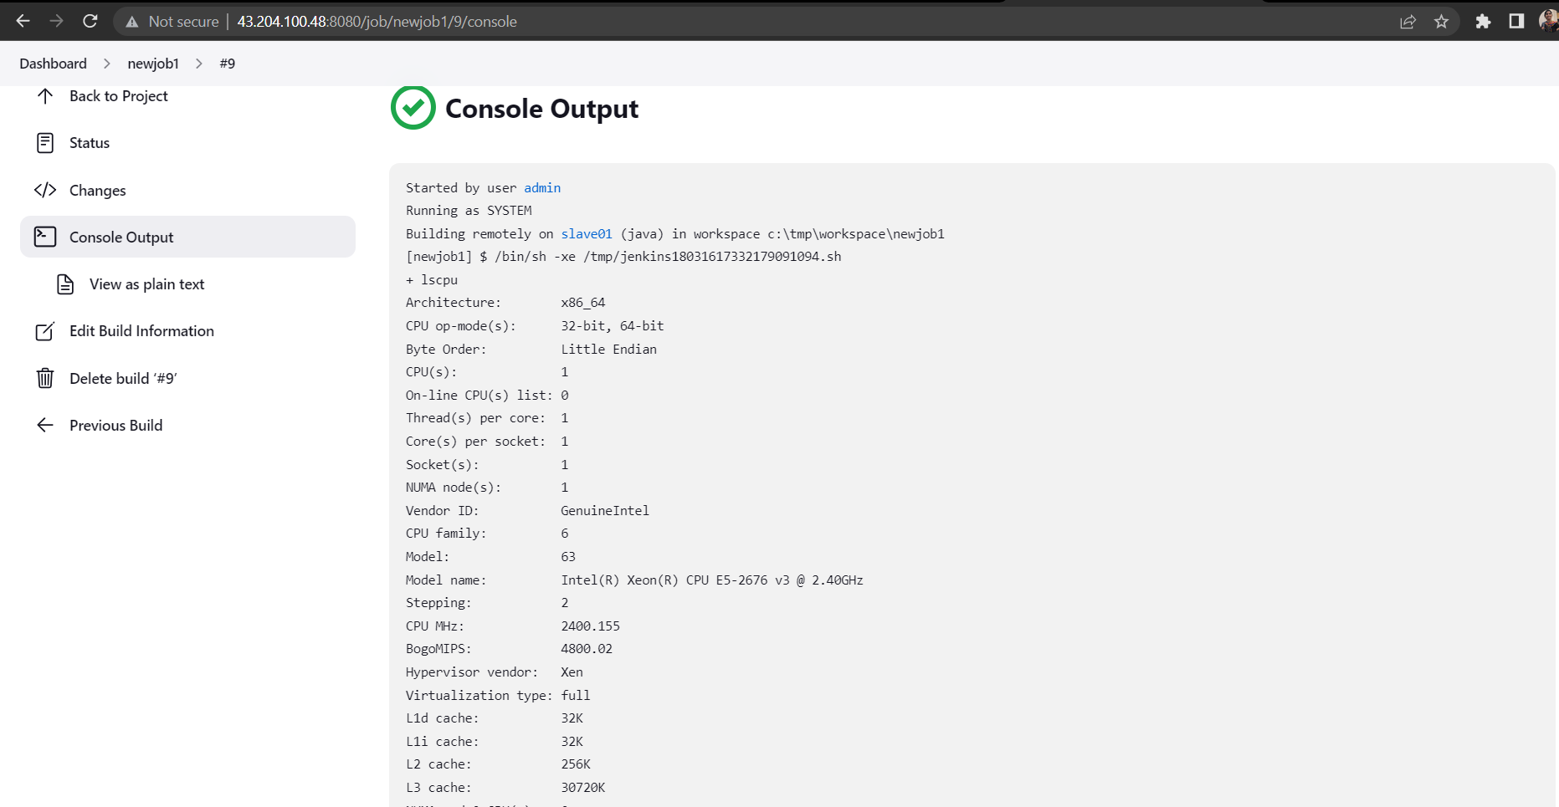

**Pipeline project:**

**Created pipeline project named pipeline01:**

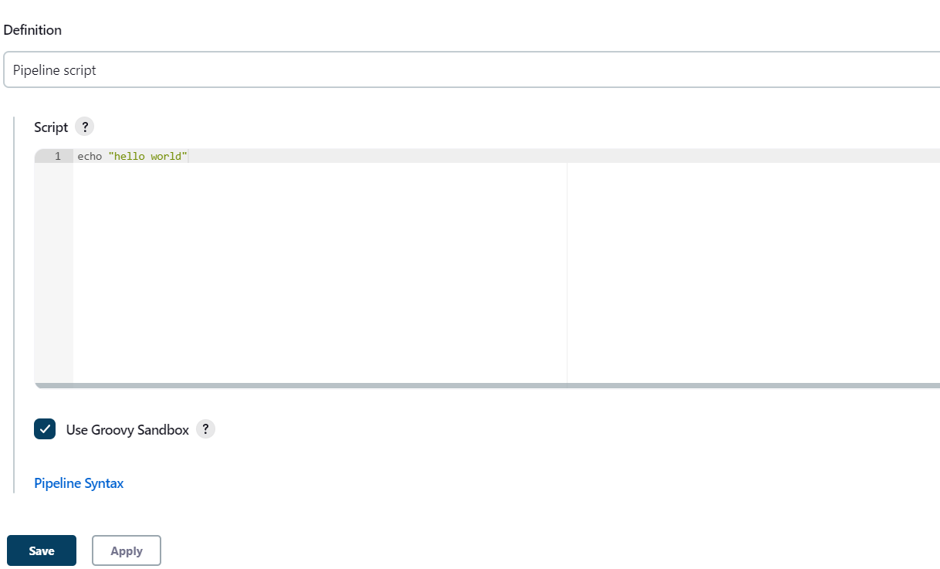

**Bulid Status:**

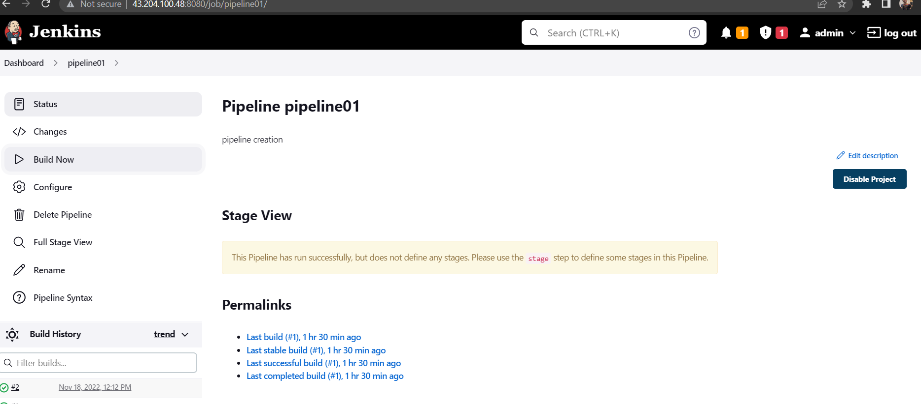

**Console o/p:**

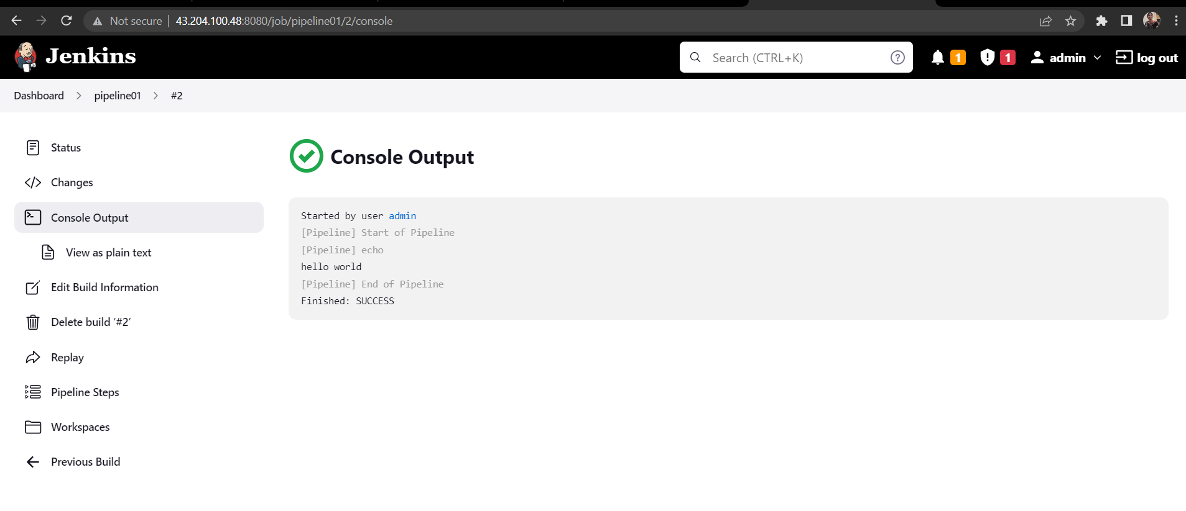

**Created pipeline with name pipelinexam**

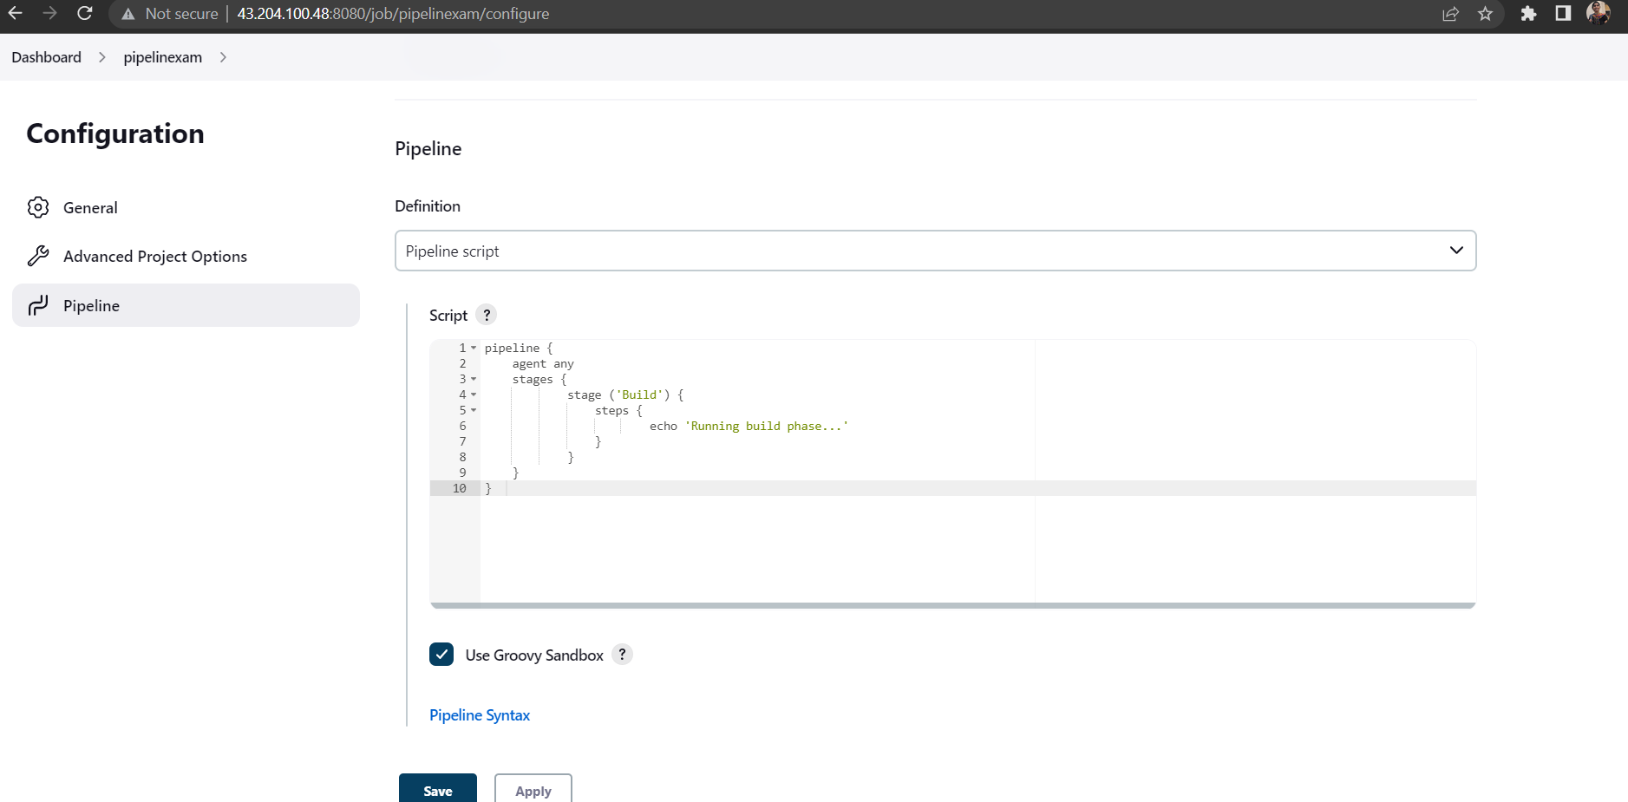

**Bulid status:**

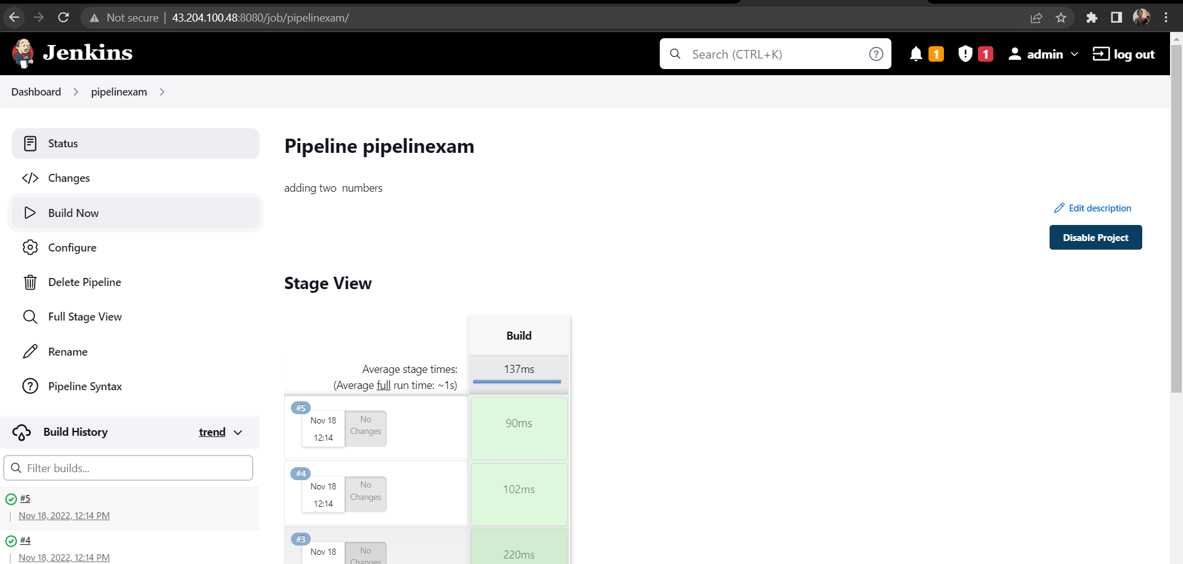

**Console o/p:**

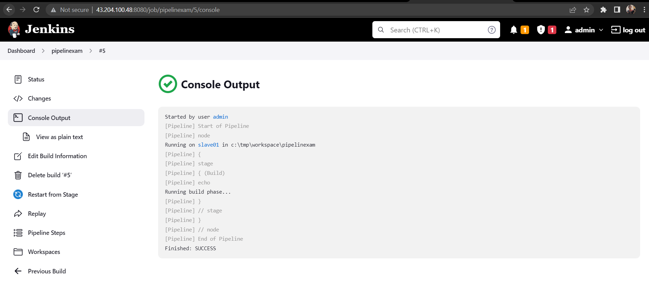

**Created a pipeline with name pipelineexample**

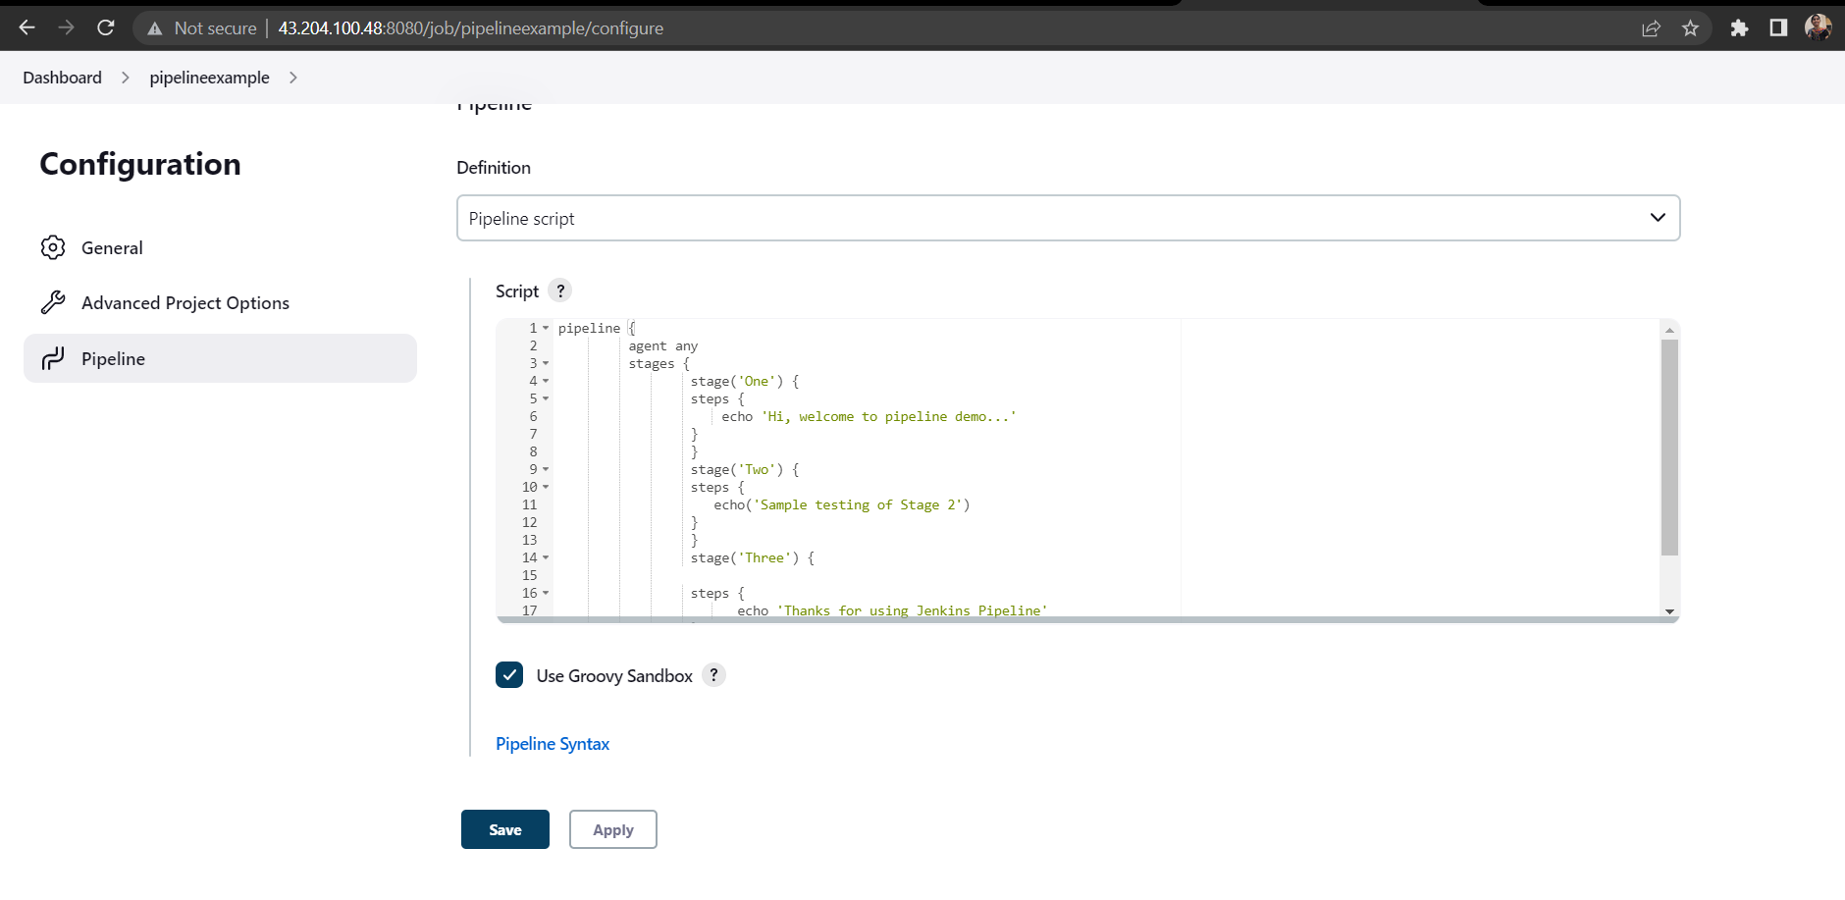

**Bulid Status:**

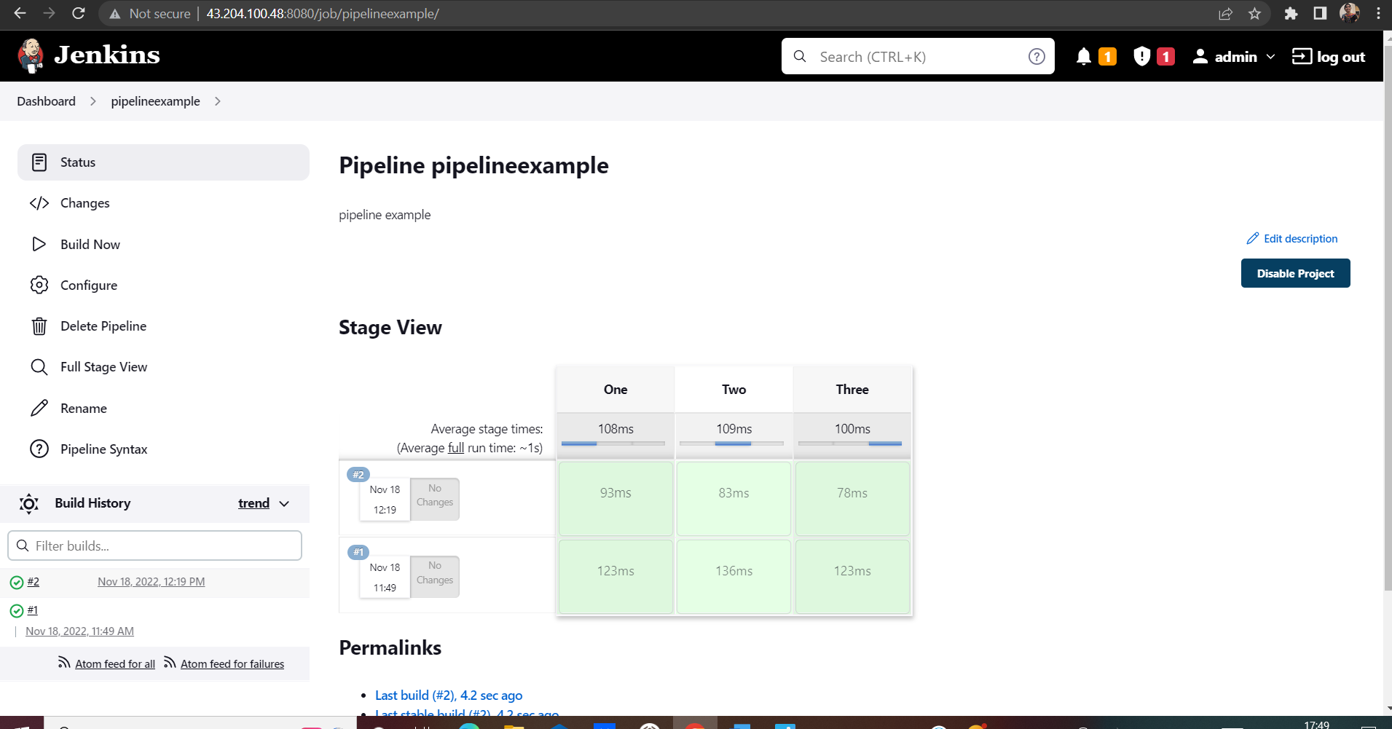

**Console o/p:**

